Supporting information
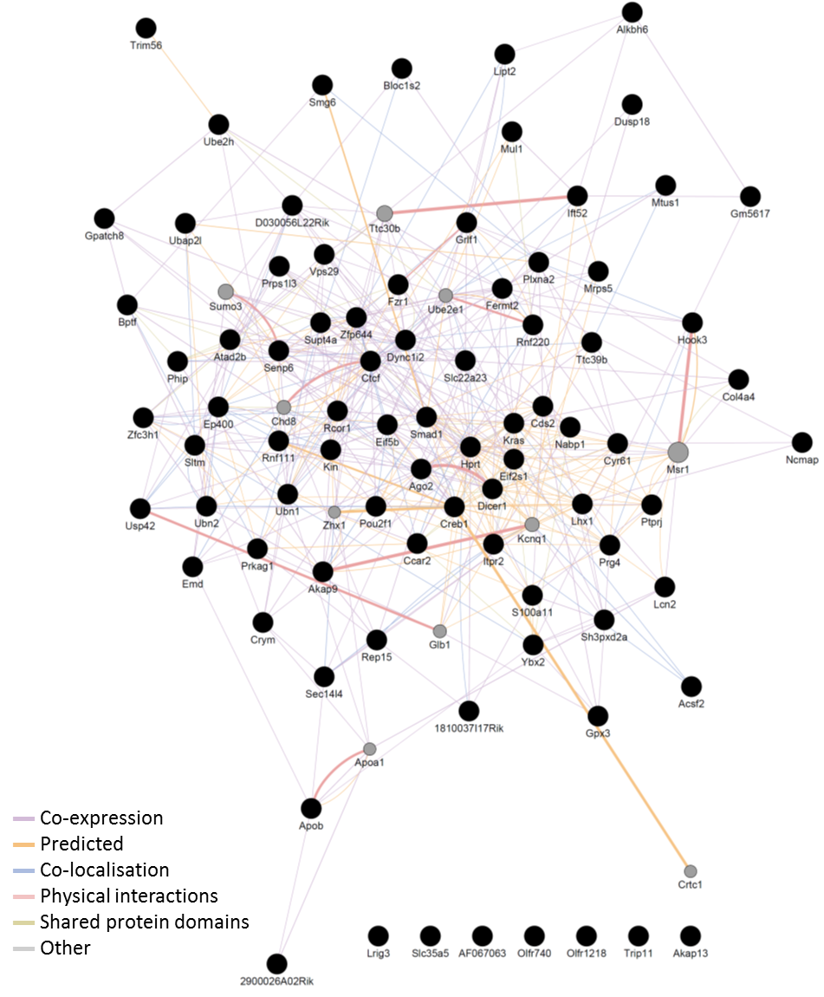
Figure S 1 Interaction network between differentially expressed genes in the liver of dams fed CMO or control diet. Solid circles indicate input genes and grey circles indicate shared neighbor genes. Line colour indicates type of interaction and line thickness indicates strength of interaction.

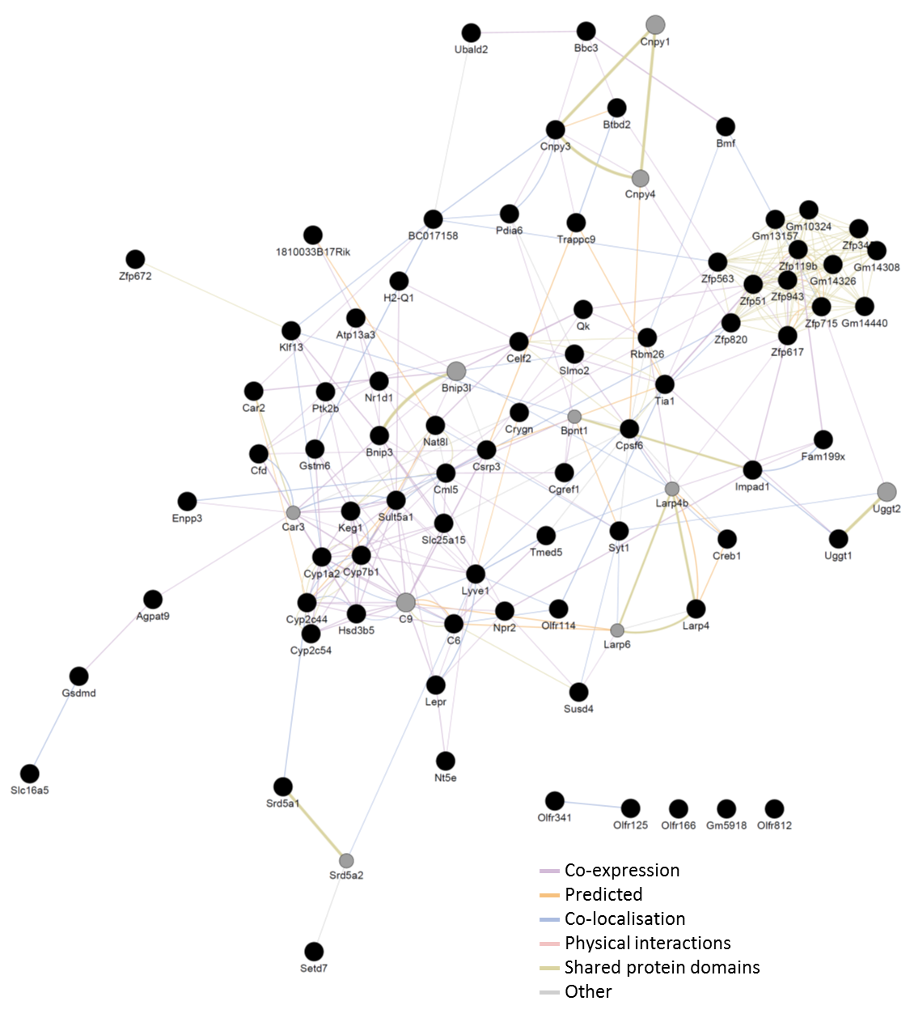
Figure S 2 Interaction network between differentially expressed genes in the liver of pups at weaning from mothers fed CMO or control diet. Solid circles indicate input genes and grey circles indicate shared neighbour genes. Line colour indicates type of interaction and line thickness indicates strength of interaction.

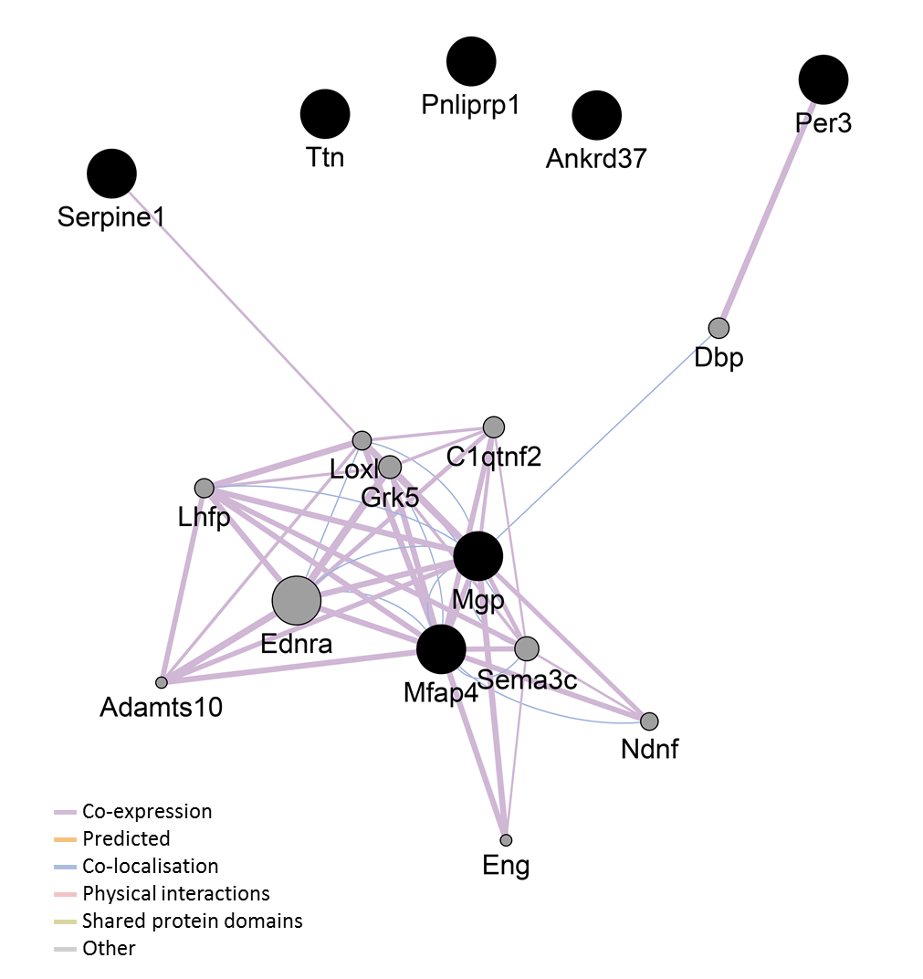
Figure S 3 Interaction network between differentially expressed genes in the liver of pups at 30 days post weaning from mothers fed CMO or control diet. Solid circles indicate input genes and grey circles indicate shared neighbor genes. Line colour indicates type of interaction and line thickness indicates strength of interaction.

